**Name:** Mansoor Tariq

**Roll No:** 20L-1369.

# **Blockchain and Cryptocurrency**

# **Assignment # 2**

# **Task 1:**

## **Install Virtual Box:**

## **Install Ubuntu Linux:**

# **Task 2:**

## **Setting up the development environment:**

### **1st Step:**

Installing Node.js v8+ LTS and npm.

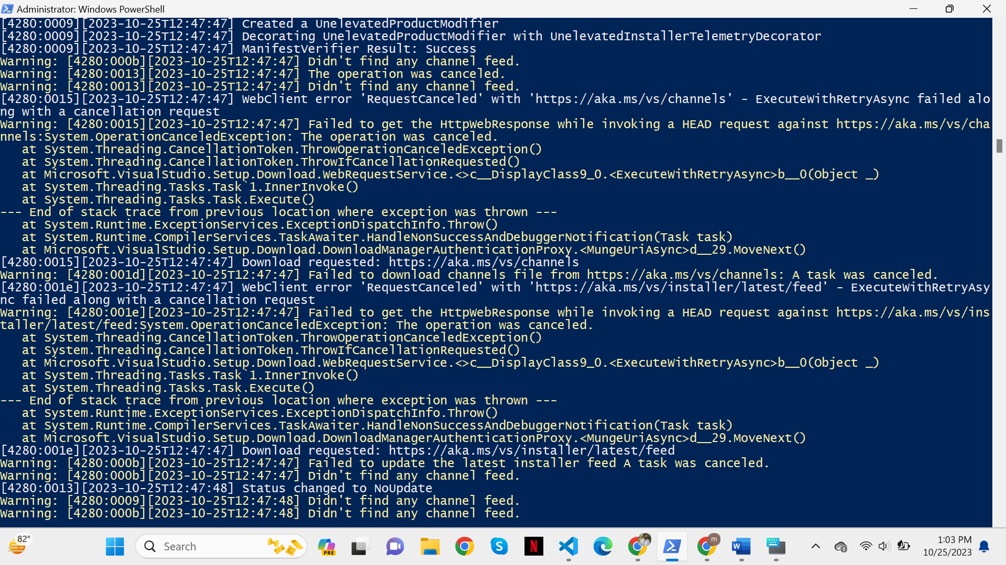

Installing Git:

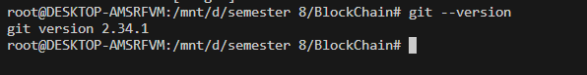

Installing truffle:

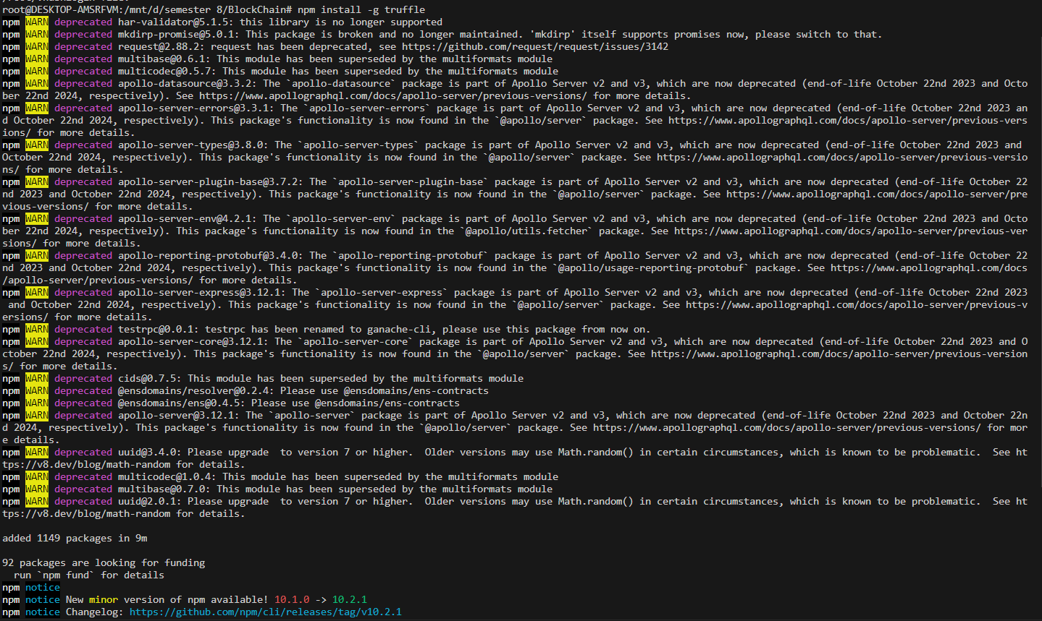

Truffle --version

## **Creating a Truffle project using a Truffle Box**

Create a directory in the development folder and then move inside it.

Using the truffle unbox command to unpack the Truffle Box

# **Task # 3:**

### **Writing the smart contract**

### **Compilation**

### **Migration**

Creating 2_deploy_contracts.js and writing content

Installing Ganache

Migrating the contract to the blockchain

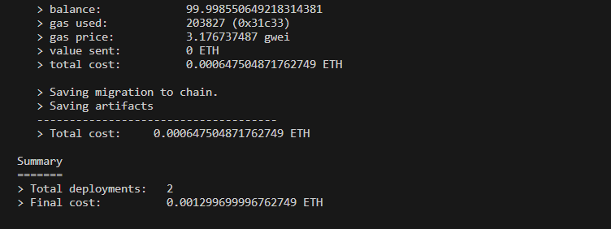

The state of Blockchain changed.



### **Testing the smart contract**

Creating two files in Test Directory

1. TestAdoption.sol

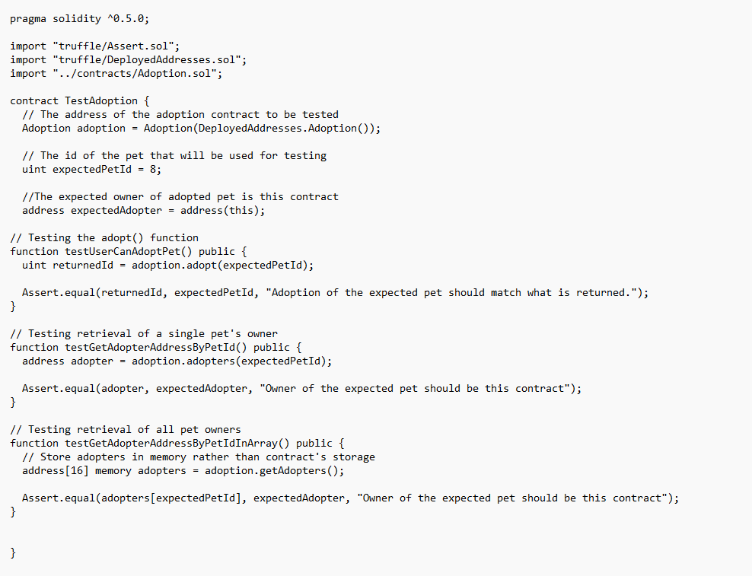

1. testAdoption.test.js

Back in the terminal, run the tests:

# **Task 4:**

Instantiating web3: Done all the changes in the file app.js

MetaMask

Creating new network

Adding money

Interacting with the dapp in a browser

Link to video:

<https://drive.google.com/file/d/1RwpS24e3McMCTEjP_1ULHgJnJ14E_Kpt/view?usp=sharing>